1. Change the design for the drop-down menu. No lines in between.
2. Remove drone from future ventures.
3. Take Awards and Recognition in ‘About Us’
4. Make the heading ribbon constant and let it have the logo on the left side and then the ribbon should be orange or yellow.(Existing Website)

Photos for the main page:

Use these pictures instead of the stock images:

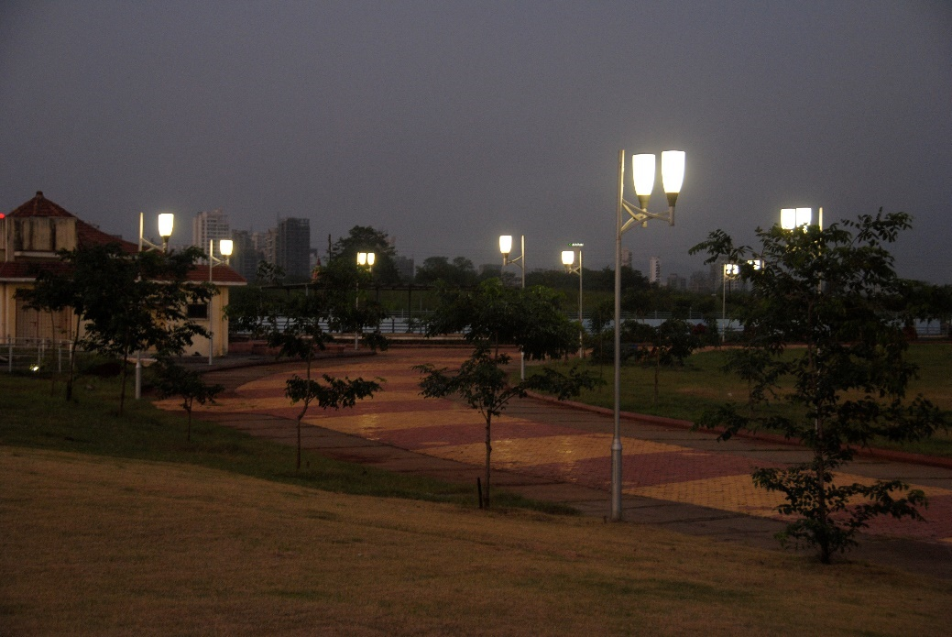

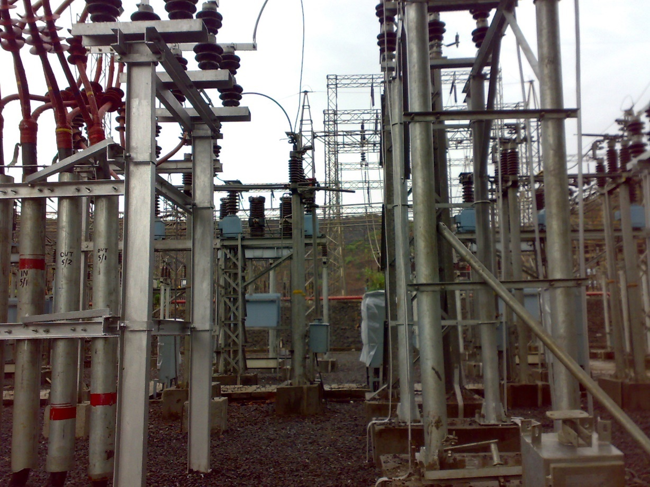

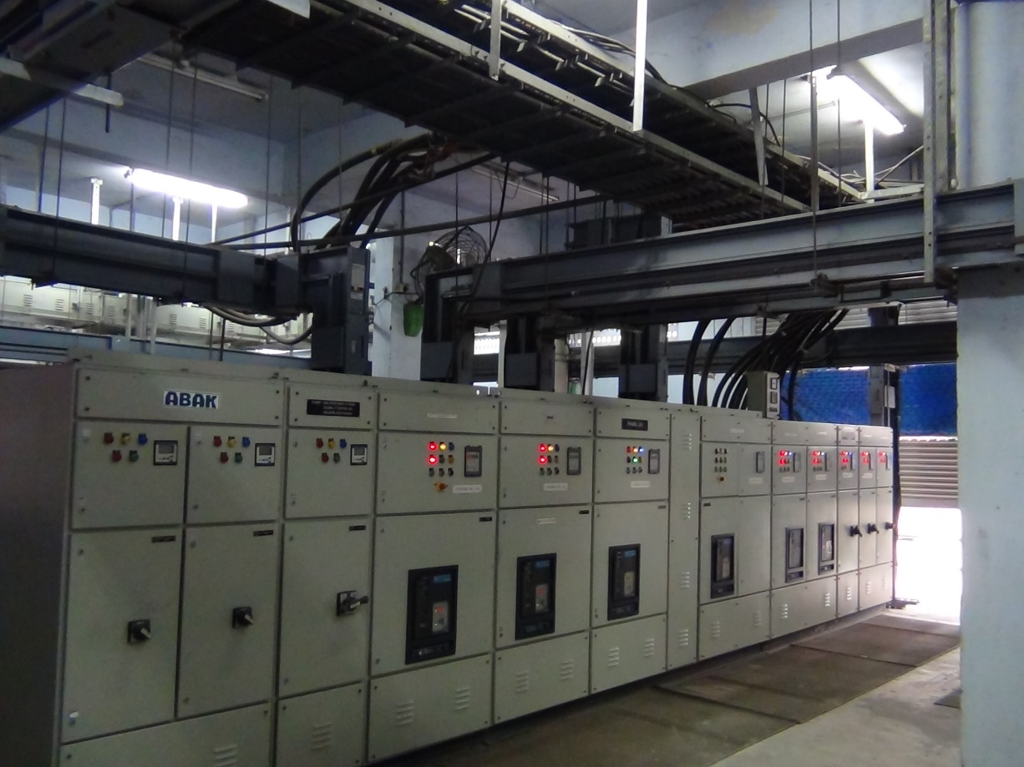

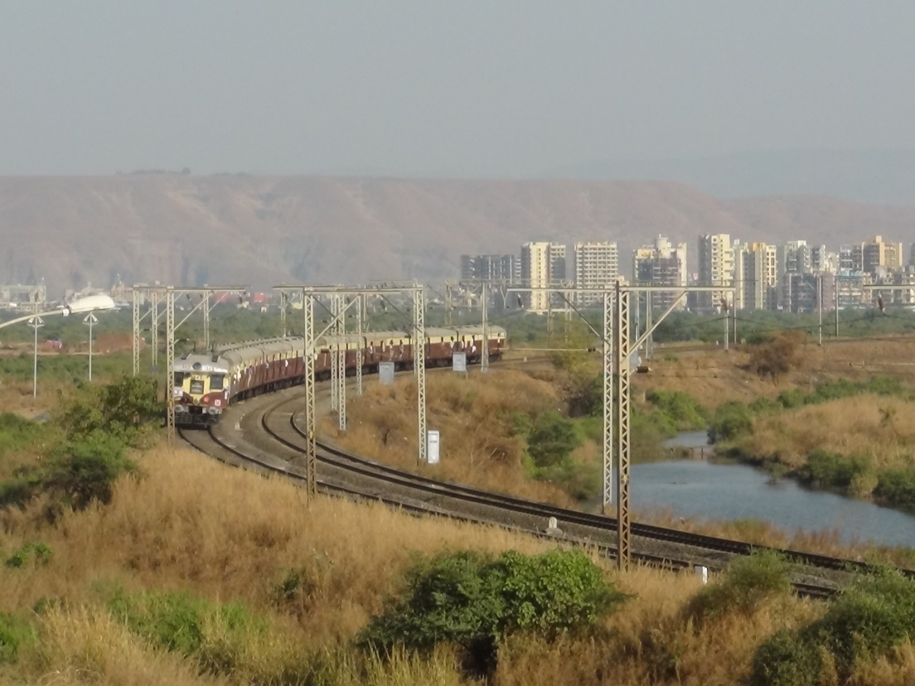

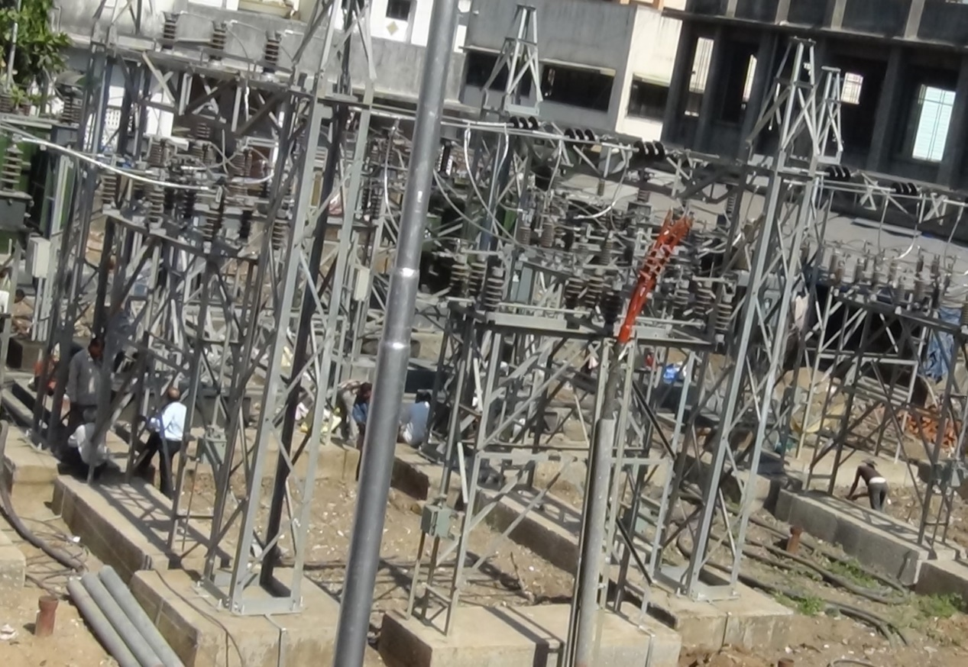

And keep the metro image

Don’t display any titles

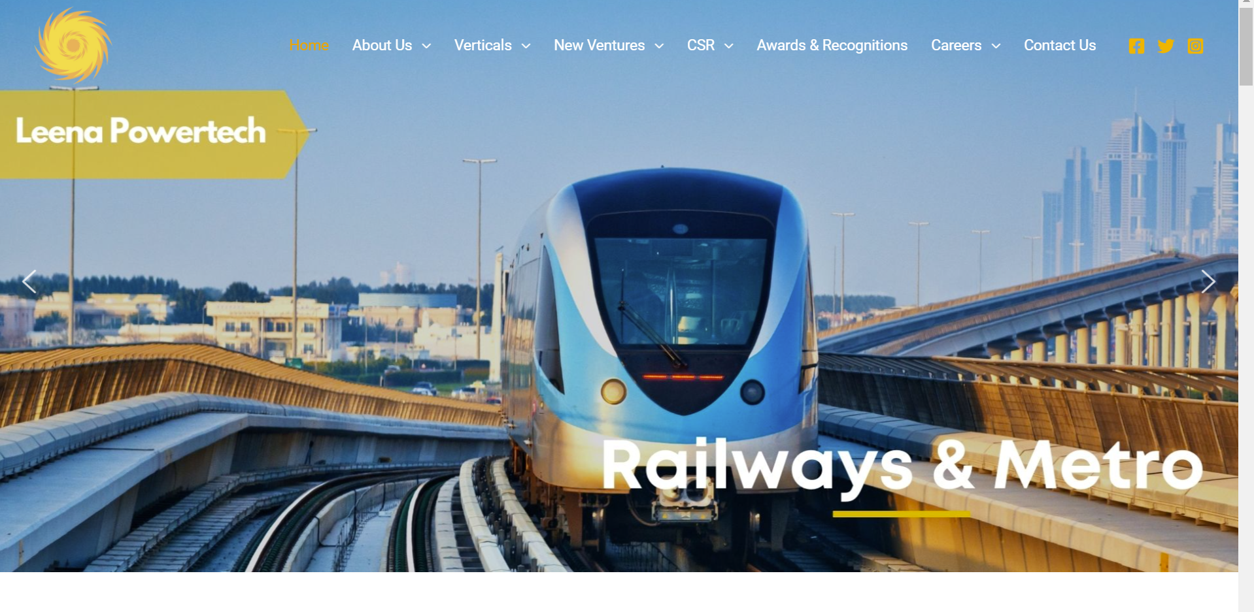

**Home page:**



**Keep this panel separate. First logo and then the title bar**

Give a link to the LinkedIn profile, and Twitter profile, maybe even Facebook.

Then we will have a WELCOME TO LEENA POWERTECH.

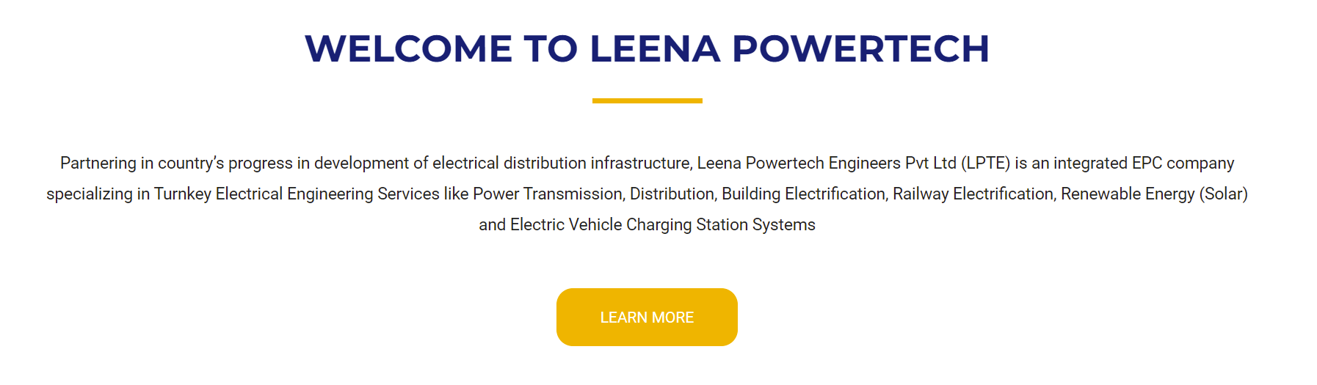

Partnering in the country’s progress in developing electrical distribution infrastructure, Leena Powertech Engineers Pvt Ltd (LPTE) is an integrated EPC company specializing in Turnkey Electrical Engineering Services.

Our work spans sectors like Power Transmission, Distribution, Building Electrification, Railway Electrification, Renewable Energy (Solar), and Electric Vehicle Charging Station Systems.

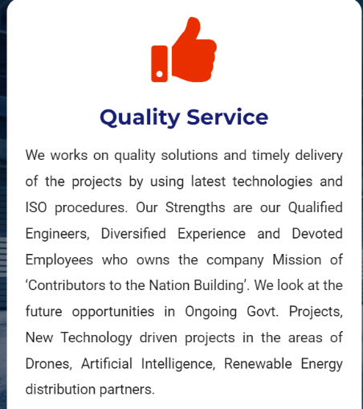We work on quality solutions and timely delivery of the projects by using latest technologies and ISO procedures. Our Strengths are our qualified engineers, Diversified Experience and Devoted Employees who believe in the company’s mission of ‘Contributors to the Nation Building’.

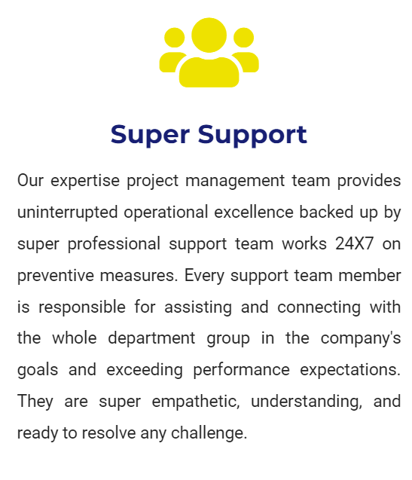

Our experienced project management team provides uninterrupted operational excellence. They are backed by a professional support team working 24x7 on preventive measures and maintenance.

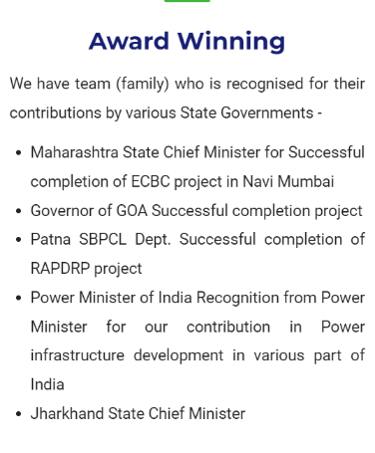Our team has been recognized for their contributions by governments all over the country. We have received prestigious awards from the Government of India, the Government of Maharashtra, the Government of Jharkhand, the Government of Goa and from many other prestigious institutions and noted individuals.

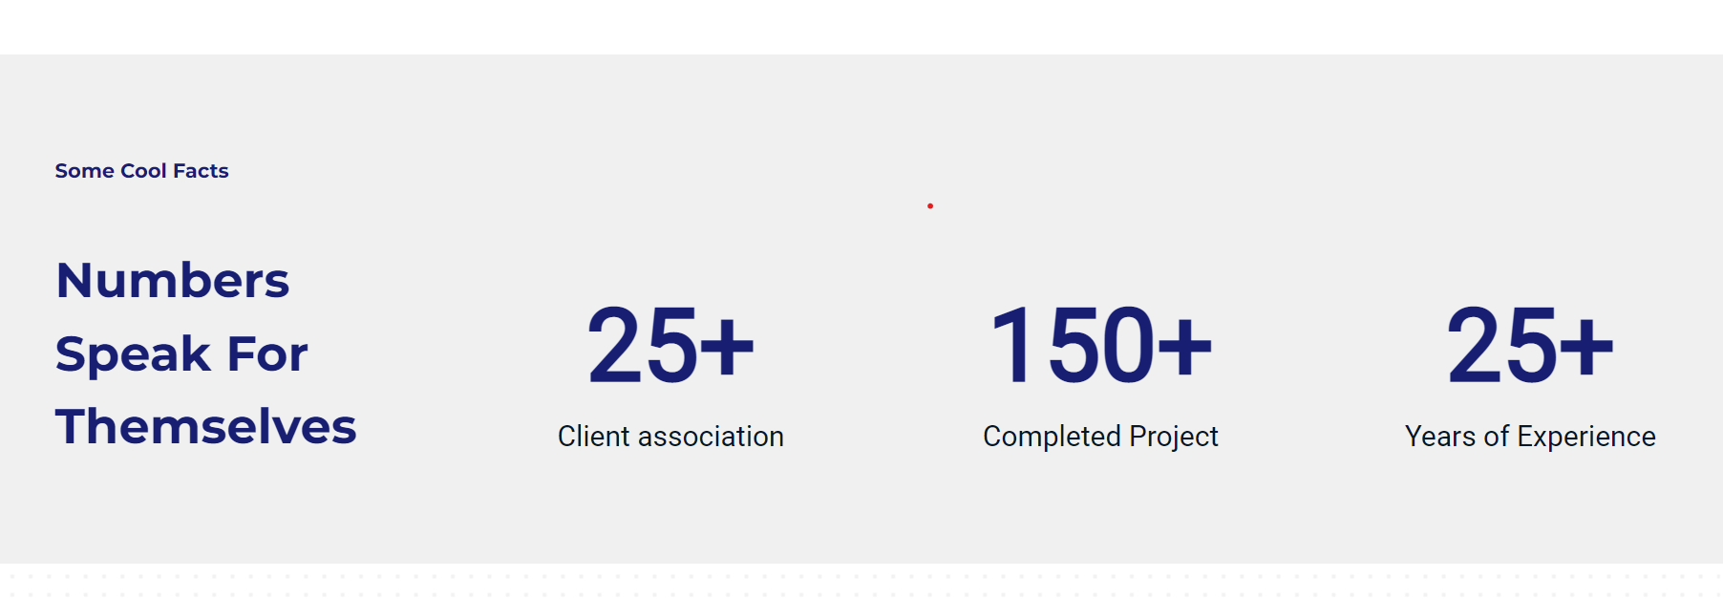



Decrease the height of this band.

Associations

Projects

Please delete ‘Some Cool Facts’

Instead of numbers speak for themselves – Keep the space blank and reduce the height of the ribbon

Add an icon above each of the numbers.

Clients, Projects, Years all should have some type of icon on top.

For the time being, distribute the three numbers with a provision to add additional numbers.

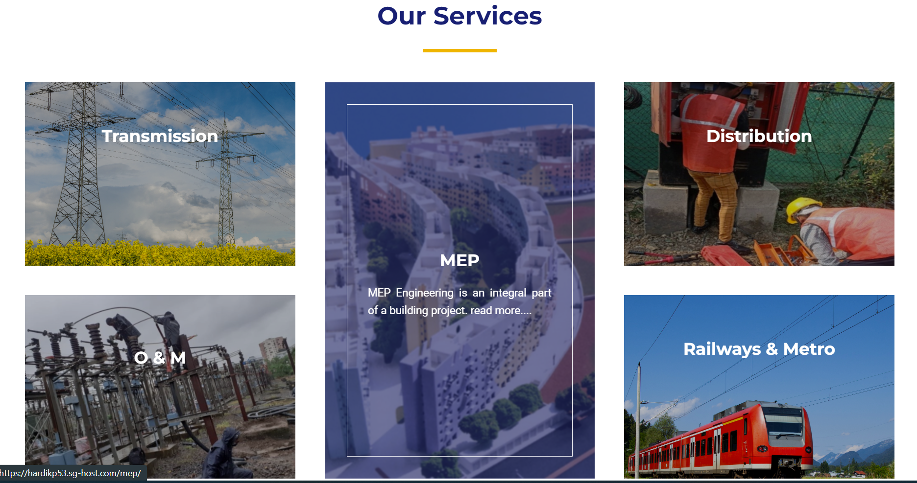

MEP or **MEP works?**



Remove the small description that comes when you hover over a block. Increase the font of the heading and place it in the center of the box.

MEP -> MEP Works

And All Caps.

Keep the titles in the middle

**About Us:**

**Company:**

**Our Team:**

**Awards and Recognition:**

**Company** (Will have the same content which is now in the About Us subsection):

Change the design. It should occupy the entire screen and not just sit in one corner of the screen.

Start with

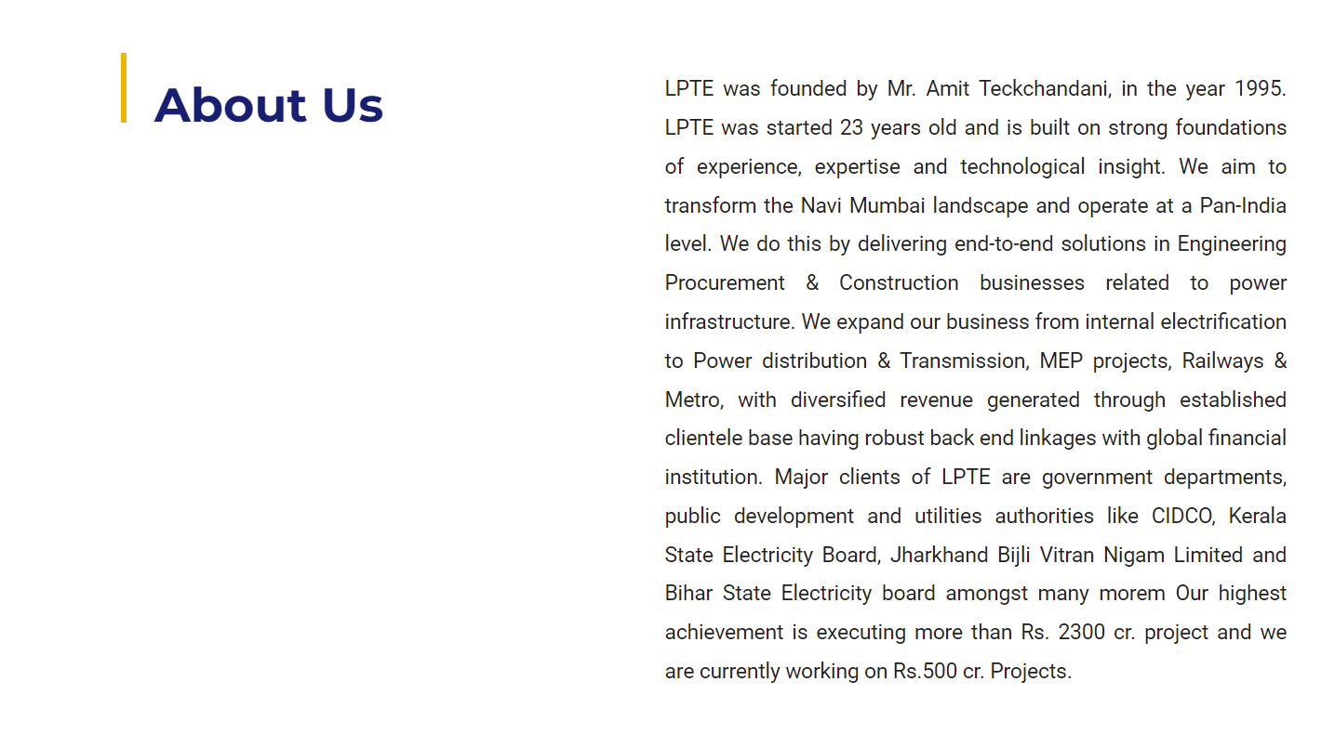

LPTE was started in 1995 and has been built on the strong foundations of experience, expertise, and technological insight. Our aim is to transform the landscape of Navi Mumbai and operate at a pan-India level. We do this by delivering end-to-end solutions in Engineering Procurement & Construction businesses related to power infrastructure. Over the years, we have worked in various field like Power distribution & Transmission, MEP projects, Railways & Metro. We mainly work with government departments, state electricity departments, public development, and utilities authorities like CIDCO, Kerala State Electricity Board, Jharkhand Bijli Vitran Nigam Limited, and Bihar State Electricity board to name a few. Having executed huge turnkey projects and amassing a vast experience of 25 years, we are now moving forward and expanding our services in the upcoming fields of Electric Vehicle infrastructure and Solar Installations.

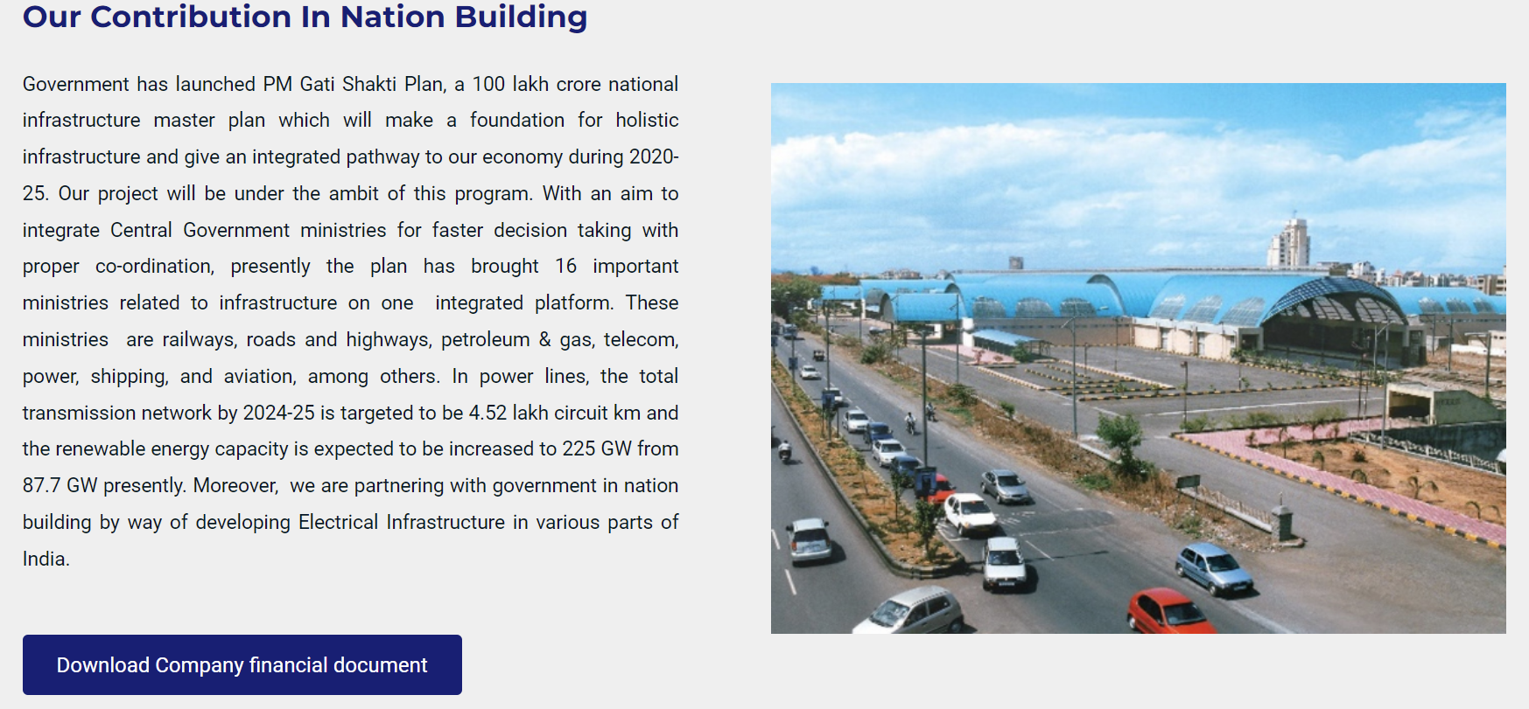

Over the years we have helped bring electricity to all parts of the country. From developing substations to electrifying buildings, we have a versatile team with a strong work ethic. We started with Navi Mumbai as our target and over the years we have expanded our scope. Now, we are in different parts of the country and are working continuously to build world class infrastructure for our nation. Our infrastructure has stood the test of time and nature. Even in adverse conditions, we were able to deliver satisfactory services. With the focus of the nation moving towards renewable energy, our team is looking onto new prospects and adapting to new technology. Our company is aligned with PM’s Gati Shakti Plan, a 100lac crore master plan to develop holistic infrastructure in the country. We truly believe in the vision and plan to contribute as much as we can in our field.

Vision and Mission:

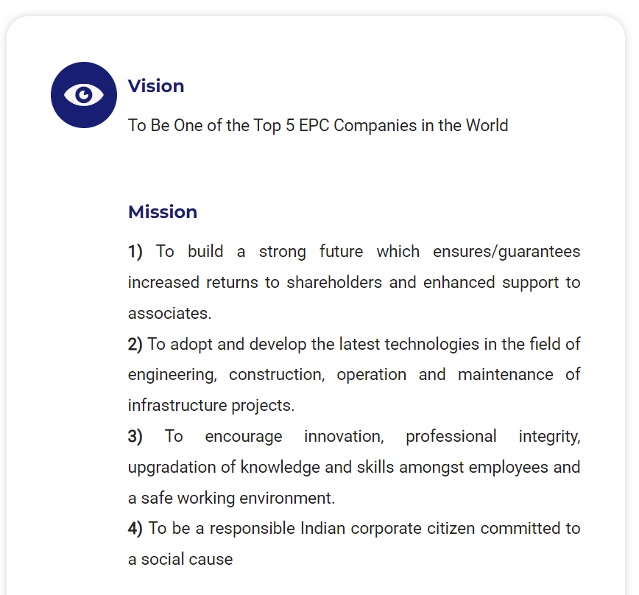

Vision Statement:

To Be One of the Top 5 EPC Companies in the World.

Change to

1. To be one of the leading EPC companies in the world.

Mission Statement:

1. To adopt and develop the latest technologies in the field of engineering, construction, operation, and maintenance of infrastructure projects.
2. To encourage innovation, professional integrity, upgradation of knowledge and skills amongst employees and a safe working environment.
3. To be a responsible Indian corporate citizen committed to a social cause.
4. To build a strong future which ensures enhanced support to associates.

Change the picture here.

**Graphical photo. (Some vision mission type graph)**

Include company policy and company financial document in this page.

Will send the revised company policy document within a day.

Company financial document should have a small link in the bottom. Not prominent.

Also include company values:

Company values:

* **Integrity:** To be fair, honest, transparent, and ethical in our conduct.
* **Loyalty:** Building mutually beneficial relationships both internally and externally that stand the test of circumstances and time.
* **Customer Satisfaction:** Creating value for our customers and delivering solutions beyond their expectations.
* **Teamwork:** Our company is full of amazing individuals, but it is only through teamwork that we achieve excellence.
* **Quality & Safety**: We adhere to the highest standards of quality and ensure customers get the best service. All our work is carried out with safety as our main priority.
* **Innovative**: To continuously try new things and take risks to break our barriers and provide our customers with the best solutions.
* **Performance**: We strive to improve our performance and encourage individuals to push their comfort boundaries.

**Our Team:**

First introduce the directors. With a small introduction for both.

Reduce the size of the photos and the description should be short with an option of Read More…

Then introduce the HODs – CFO, CEO and HRM

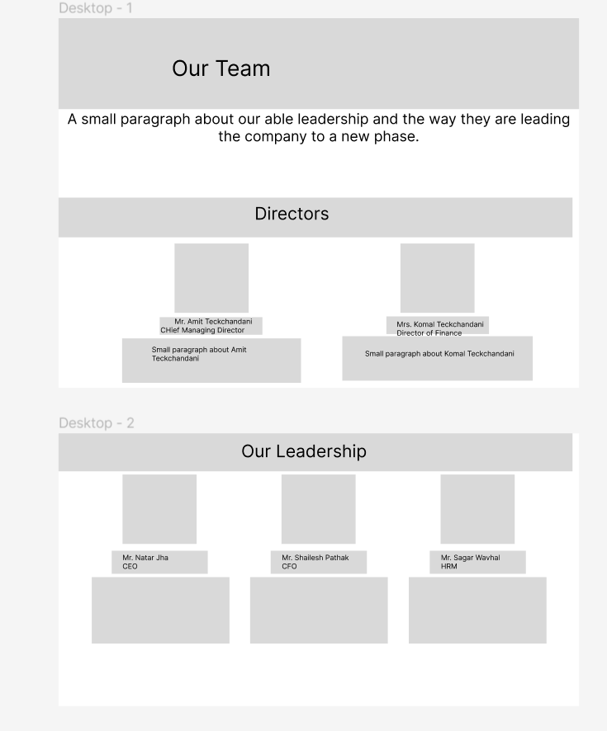

Amit Teckchandani:

Mr. Amit Teckchandani is the founder of Leena Powertech and the Chief Managing Director of Leena Powertech. He is a first-generation entrepreneur and has been the driving force in Leena Powertech’s success over the decades. He is a passionate individual and believes in the principle ‘Look beyond yourself’.

Komal Teckchandani.

A successful software engineer and our co-founder, Mrs. Komal Teckchandani is the Director of Finance. Her enthusiastic and vibrant approach has helped Leena Powertech to go beyond boundaries. She has been a staunch figure in Leena Powertech’s success over the years.

Natwar Jha:

Mr. Natwar Jha, Chief Executive Officer, has immense experience in his field. A highly qualified engineer and a committed person, Mr. Natwar believes in creating value for our customers. With his exceptional execution skills and planning, he has taken Leena Powertech to new heights.

Shailesh Pathak:

Mr. Shailesh Pathak, Chief Financial Officer, is an accomplished Chartered Accountant. He is an energetic individual and believes in thinking beyond the book. With a progressive attitude, he has been driving Leena Powertech’s rise in recent years.

Sagar Wavhal:

Mr. Sagar Wavhal, Human Resource Manager. He is an expert in his field, and he is a highly experienced and distinguished individual. With an eye on the future, he is working to improve operational performance and build a solid foundation.

No contact option for any of them.

**Awards and Recognition:**

Introduction:

Our company is one of the leading EPC companies in the country. This can be demonstrated by the numerous prestigious awards our team has received from many governments like the Government of Maharashtra, Government of Goa, and the Government of Jharkhand. Here are some of the phots of our team receiving accolades.

The five photos are good.

**Verticals:**

**MEP:**



Just ‘Our Expertise’

MEP Engineering is an integral part of a building. We are responsible for planning and designing MEP systems, including developing policy standards, inspection procedures and evaluation tools for MEP concerns. Our team specializes in preparing project reports, reviewing, drawing, specification, and cost estimates for the MEP project.

The photos in the middle.

We have executed more than 30 major projects costing having a total value of more than 150 Cr for clients such as CIDCO, SBI, and IDBI amongst many others.

**Transmission:**

Introduction:

LPTE is capable of proficiently erecting GIS, AIS, and EHV substations, designing AC traction HV Substation of 110/220/400 KV, constructing110/220 KV Tower & monopole Transmission Lines, and laying EHV cabling.

**Distribution:**

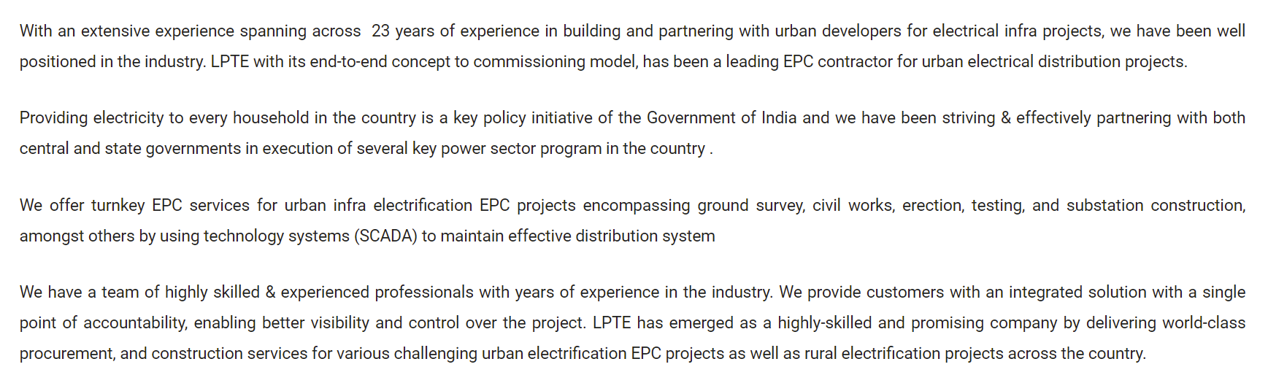



SCADA is a good credential. Something more about it.

We were one of the first companies to successfully execute and commission a SCADA system.

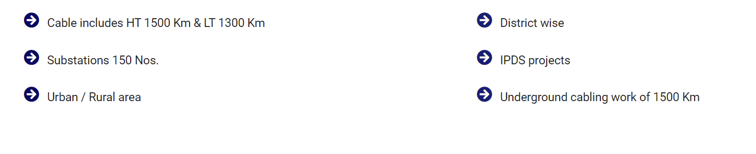

Six points:

1. HT cable 1500km
2. LT cable 1300km
3. Around 150 Substations
4. Urban and Rural area expertise
5. Executed IPDS projects
6. Underground cabling of more than 1500km

**Operation and Maintenance:**

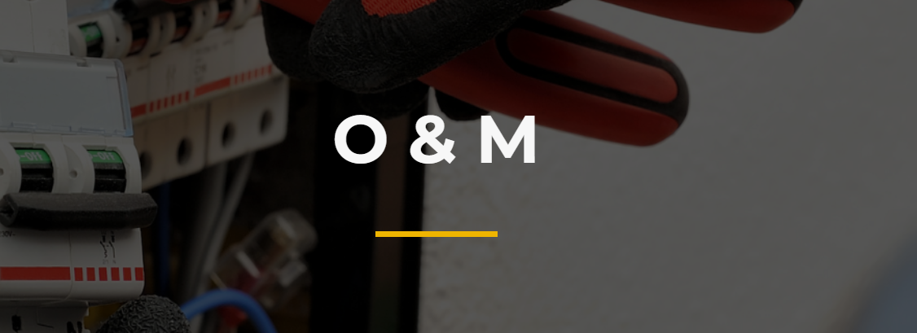

O&M 🡪 Operation and Maintenance with all of them in different lines.

Electrical systems need to ensure continued compliance with periodic servicing and repair. Our team helps in maintaining electrical systems like substations, overhead & underground electrical distribution system, and exterior lighting system to ensure that they work without any hindrance for a long time. Such maintenance helps to prevent system and equipment failure while ensuring maximum safety and efficiency in the utilization of the facilities.

We have done maintenance work in numerous places in Navi Mumbai like Nerul station, Baman Dongri station, Kharghar metro, and Bhoomiputra Bhavan. We help the utilities and power companies in maximizing their efficiency and providing their consumers with uninterrupted service.

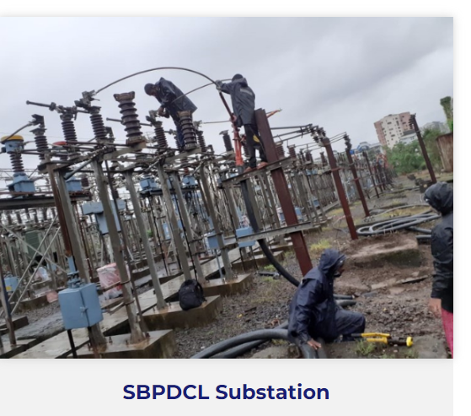

Instead of SBPDCL Substation – Patna Substation.

**Railways and metros:**

Metro railways in urban areas have grown exponentially across the country and the volume of passengers continue to grow for rail transit systems for a safe, affordable, and reliable transportation service. LPTE has strategically ventured into this business vertical which shall contribute to growth of Indian infrastructure.

LPTE assists in metro rail electrification projects by enabling integrated project execution with increased efficiency, stringent safety measures and higher visibility across all projects. LPTE offers its competence in design, engineering, installation, testing, and commissioning of multi-disciplinary metro & rail projects with the capability to build, power and connect substations. Our skills, experience and capability lie in power and electrification of overhead lines, including the installation of new lines, integration with multiple stake holders for common interest in the growth of nation building.

Try to bring all MMRDA photos under one sub- heading. Same thing for the Baman Dongri photos.

**New Ventures:**

**Solar System Installations:**

**Introduction:**

Solar power is an integral part of the vision to completely rely on renewable energy. Along with the right technology it is also important to provide the right execution to make solar power accessible to the public. We are aligned with this vision and want to make solar power convenient for everyone in the country. Starting with rooftop installations for residential buildings and workplaces, we are now moving forward to implement large scale implementations and provide more solar power to the grid.

**EVCS:**

**Introduction:**

The given write up is good

**Photos:**

Give provision for photos at the bottom.

**Lift and Escalators:**

Introduction:

With increasing modernization of places across the country, our company has forayed into the business of lifts and escalators. In collaboration with our partners, we provide seamless solutions to make places more accessible.

Photos:

For the time being add a stock image for lift and escalator. Please give a provision for more photos.

**CSR:**

**Remove drop down. Just CSR**

Remove CSR points from the webpage.

First mention Plantation activity

And then mention the National Safety Week

Same photos

**Write up for Plantation activity:**

During our work in Satpati, our company ran a program that encouraged the people of the town to plant trees in their area. Our team visited the schools in the area to educate the children about saving our environment.

Then display the photos

**Write up for National Safety Week:**

Every year in the month of March, we run campaigns on all our sites to make people aware about the SHE(Safety, Health and Environment) movement, and to motivate people to create safer workplaces.

Both activities on the same page

**Careers:**

**Join the team:**

Mention Careers in the ribbon but Join the Team should be heading when we open the page.

LPTE is a professionally managed EPC company with employment policies and systems that radiate from a single principle "Believe in people". People are our most valued assets and strength. At LPTE we believe that taking care of our team and encouraging them is an important part of our culture. We regularly provide our teams the opportunity to reinvigorate themselves through various motivational programs like picnics, sports facilities, movie shows, birthday celebrations, etc.

At LPTE, our HR Policies are liberal and employee friendly. We value our employees and extend all support and co-operation for their professional development and providing career growth plan. HR plays the role of catalyst and acts as a voice of employee in order to improve employee's contribution and achieving business goals.

**HR initiatives**

Shift to company policy. Delete from this page.

**Contact Us**

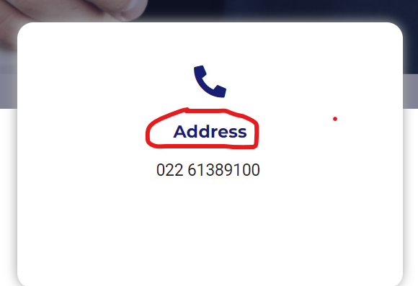Change the address to ‘Telephone’.

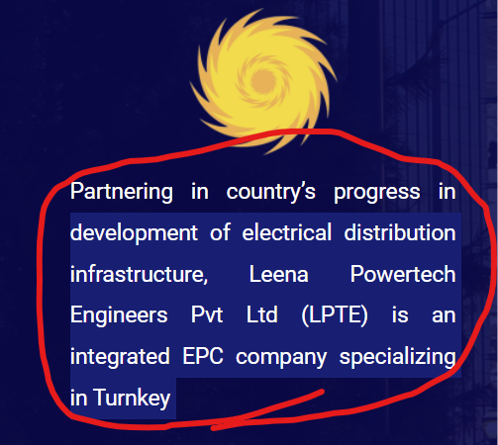

Instead of this paragraph here add a tag line.

Just mention ‘Connecting People and Power’

Format: Logo | Tagline